Technical Report Writing & Presentation
BS Computer Science, Batch 2022F

Information Report
Spain’s Use of Artificial Intelligence in Higher Education

Submitted by:
Name | Roll Number
Muhammad Faisal | 2022F-BCS-152
Muzamil | 2022F-BCS-316



BS in Computer Science
Department of Computer Science & Information Technology
University Road Karachi – 75300
http://www.ssuet.edu.pk

Information Report: Spain’s Use of Artificial Intelligence in Higher Education

Introduction
Spain is emerging as a global leader in integrating Artificial Intelligence (AI) into higher education, leveraging its rich academic heritage and forward-thinking policies to modernize its educational system. With institutions like the University of Salamanca, founded in 1218 and one of the oldest universities in the world, Spain is blending tradition with innovation. Through national initiatives such as the Digital Spain 2025 strategy and participation in European programs like Horizon Europe, Spain is actively incorporating AI to enhance learning, research, and administrative efficiency in its universities. This report explores how Spain is using AI in higher education, highlighting key applications, strategies, and challenges.

AI Applications in Spanish Higher Education
- Personalized Learning
Spanish universities are using AI to create adaptive learning environments tailored to individual student needs. For example, the University of Valencia employs AI-driven platforms to analyze student performance data and identify areas where learners struggle. These platforms then recommend personalized resources, such as additional reading materials or practice exercises, to help students improve. Similarly, the University of Salamanca uses AI-powered tools to provide real-time feedback on assignments, enabling students to track their progress and refine their skills.
- Enhanced Research Capabilities
AI is revolutionizing research in Spanish universities by enabling the analysis of large datasets and accelerating discoveries. The Polytechnic University of Catalonia has integrated AI into its research labs, focusing on areas like robotics, natural language processing, and AI ethics. For instance, AI algorithms are being used to analyze medical data for early disease detection and to model climate change impacts. These advancements are positioning Spain as a hub for cutting-edge research in Europe.
- Streamlined Administrative Processes
AI is transforming administrative tasks in Spanish universities, making operations more efficient and reducing faculty workload. The University of Barcelona has implemented AI-powered chatbots to handle student inquiries about admissions, course registration, and campus services. These chatbots provide instant responses, freeing up staff to focus on more complex tasks. Additionally, AI tools are being used for automated grading, scheduling, and document verification, further enhancing operational efficiency.
- Industry Collaboration and Practical Training
Spanish universities are partnering with leading tech companies to integrate AI into their curricula and provide students with hands-on experience. For example, the University of Salamanca collaborates with IBM to offer training programs in AI technologies, including machine learning and data analytics. Similarly, the Polytechnic University of Madrid works with Microsoft and Telefónica to organize hackathons and workshops, giving students the opportunity to apply AI in real-world scenarios. These partnerships ensure that graduates are well-prepared for the demands of the modern workforce.

National and European Support for AI in Education
Spain’s commitment to AI in higher education is reinforced by robust national and European policies:
- Digital Spain 2025: This national strategy aims to modernize Spain’s education system by investing in AI infrastructure, digital skills training, and research. It includes funding for AI projects in universities and initiatives to promote AI literacy among students and educators.
- Horizon Europe: As part of the European Union’s flagship research program, Spanish universities are participating in AI-focused projects that emphasize sustainability, inclusivity, and ethical AI practices.
- Educa en Digital Program: This government initiative focuses on equipping educators and students with digital skills, including AI literacy, to ensure they can thrive in a technology-driven world.
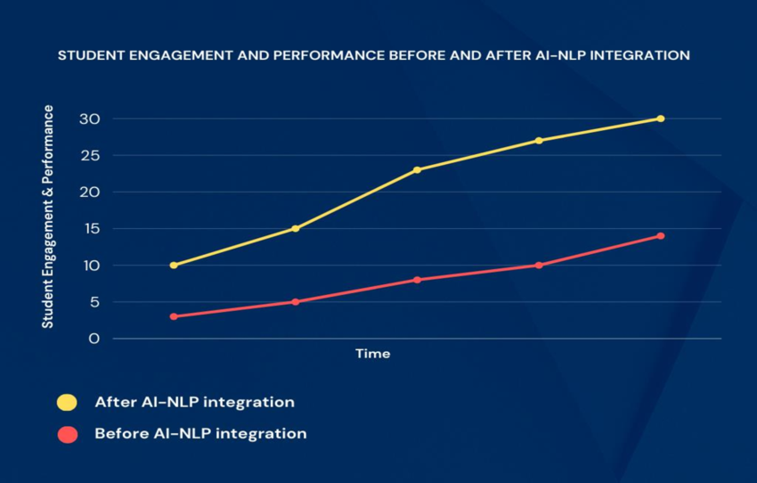

Bar chart comparing student engagement levels in traditional vs. AIpowered learning environments

Challenges and Opportunities
- Challenges
  - Resource Disparities: Smaller universities and institutions in rural areas often lack the funding and infrastructure to implement advanced AI systems.
  - Skill Gaps: There is a need for more educators trained in AI technologies and methodologies to effectively integrate AI into teaching and research.
  - Ethical Concerns: Ensuring fairness, transparency, and accountability in AI applications remains a critical challenge, particularly in areas like automated grading and data privacy.

- Opportunities
  - Global Leadership: Spain has the potential to become a global leader in AI education by leveraging its strong academic institutions and innovative policies.
  - Increased Accessibility: AI can help bridge educational gaps by providing personalized learning opportunities to underserved communities, including rural areas and students with disabilities.
  - Future-Ready Workforce: By equipping students with AI skills, Spain is preparing them for high-demand careers in fields like data science, AI development, and robotics.
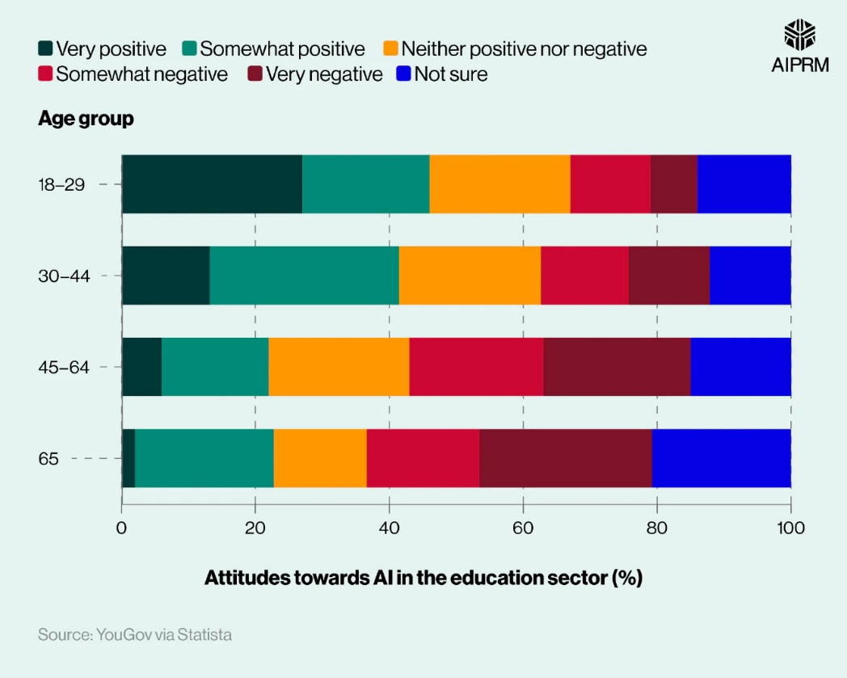

Conclusion
Spain is at the forefront of integrating AI into higher education, using innovative technologies to enhance learning, research, and administrative efficiency. Institutions like the University of Salamanca and the Polytechnic University of Madrid are leading the way, demonstrating how AI can be used to create personalized learning experiences, streamline operations, and foster groundbreaking research. Supported by national strategies like Digital Spain 2025 and European programs like Horizon Europe, Spain is well-positioned to maintain its leadership in AI-driven education. While challenges such as resource disparities and ethical concerns remain, the opportunities for growth and innovation are immense. By continuing to invest in AI and prioritize ethical practices, Spain is ensuring that its students are prepared to excel in an increasingly AI-driven world.

